**IF THEN ELSE Statement:**

DECLARE

v_myage NUMBER:=10;

BEGIN

IF v_myage < 11

THEN

DBMS_OUTPUT.PUT_LINE('I am a child');

ELSE

DBMS_OUTPUT.PUT_LINE('I am not a child');

END IF;

END;

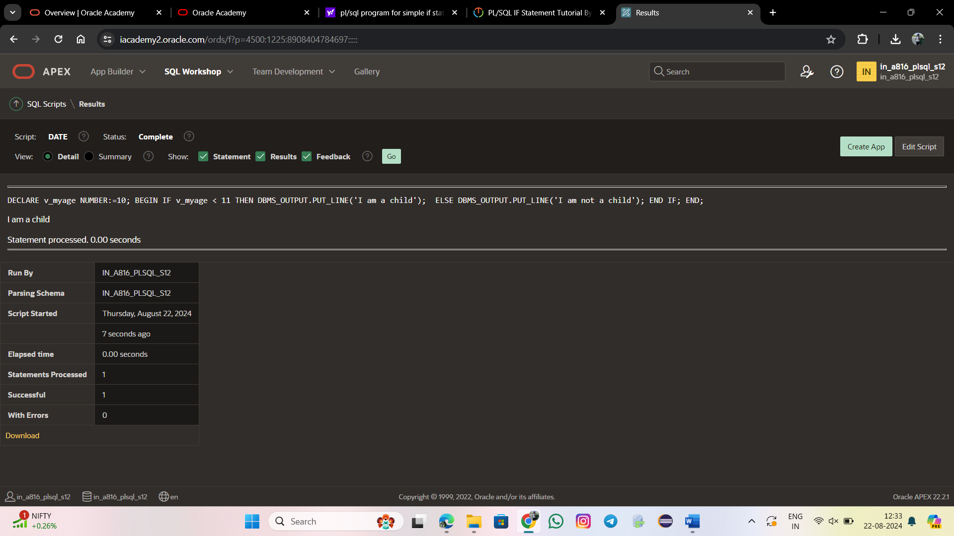

**IF ELSIF ELSE Clause:**

DECLARE

v_myage NUMBER := 31;

BEGIN

IF v_myage < 11

THEN

DBMS_OUTPUT.PUT_LINE('I am a child');

ELSIF v_myage < 20

THEN

DBMS_OUTPUT.PUT_LINE('I am young');

ELSIF v_myage < 30

THEN

DBMS_OUTPUT.PUT_LINE('I am in my twenties');

ELSIF v_myage < 40

THEN

DBMS_OUTPUT.PUT_LINE('I am in my thirties');

ELSE

DBMS_OUTPUT.PUT_LINE('I am mature');

END IF;

END;

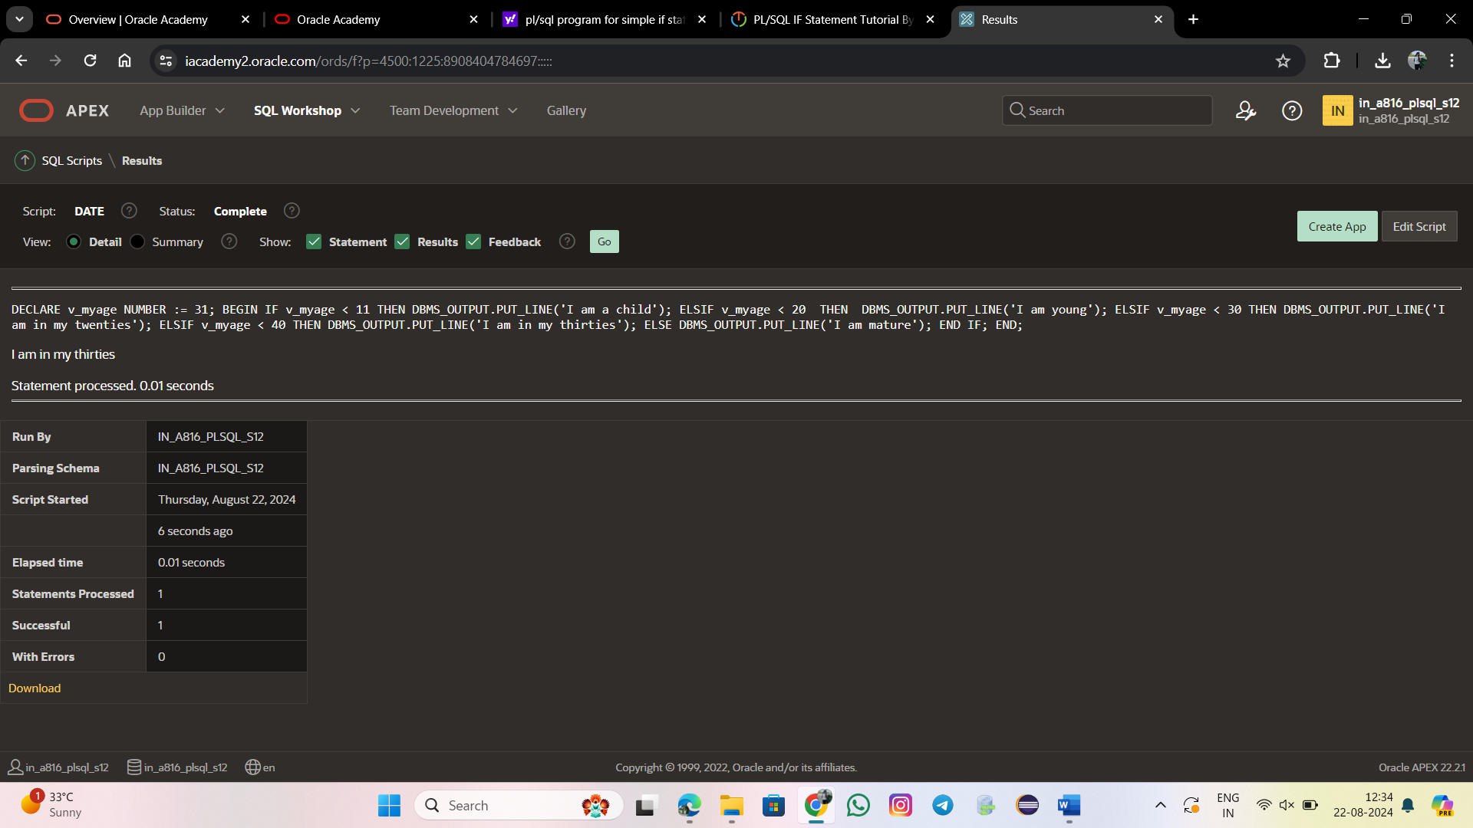

**IF Statement with Multiple Expressions:**

DECLARE

v_myage NUMBER := 10;

v_myfirstname VARCHAR2(11) := 'Christopher';

BEGIN

IF v_myfirstname ='Christopher' AND v_myage < 11

THEN

DBMS_OUTPUT.PUT_LINE('I am a child named Christopher');

END IF;

END;

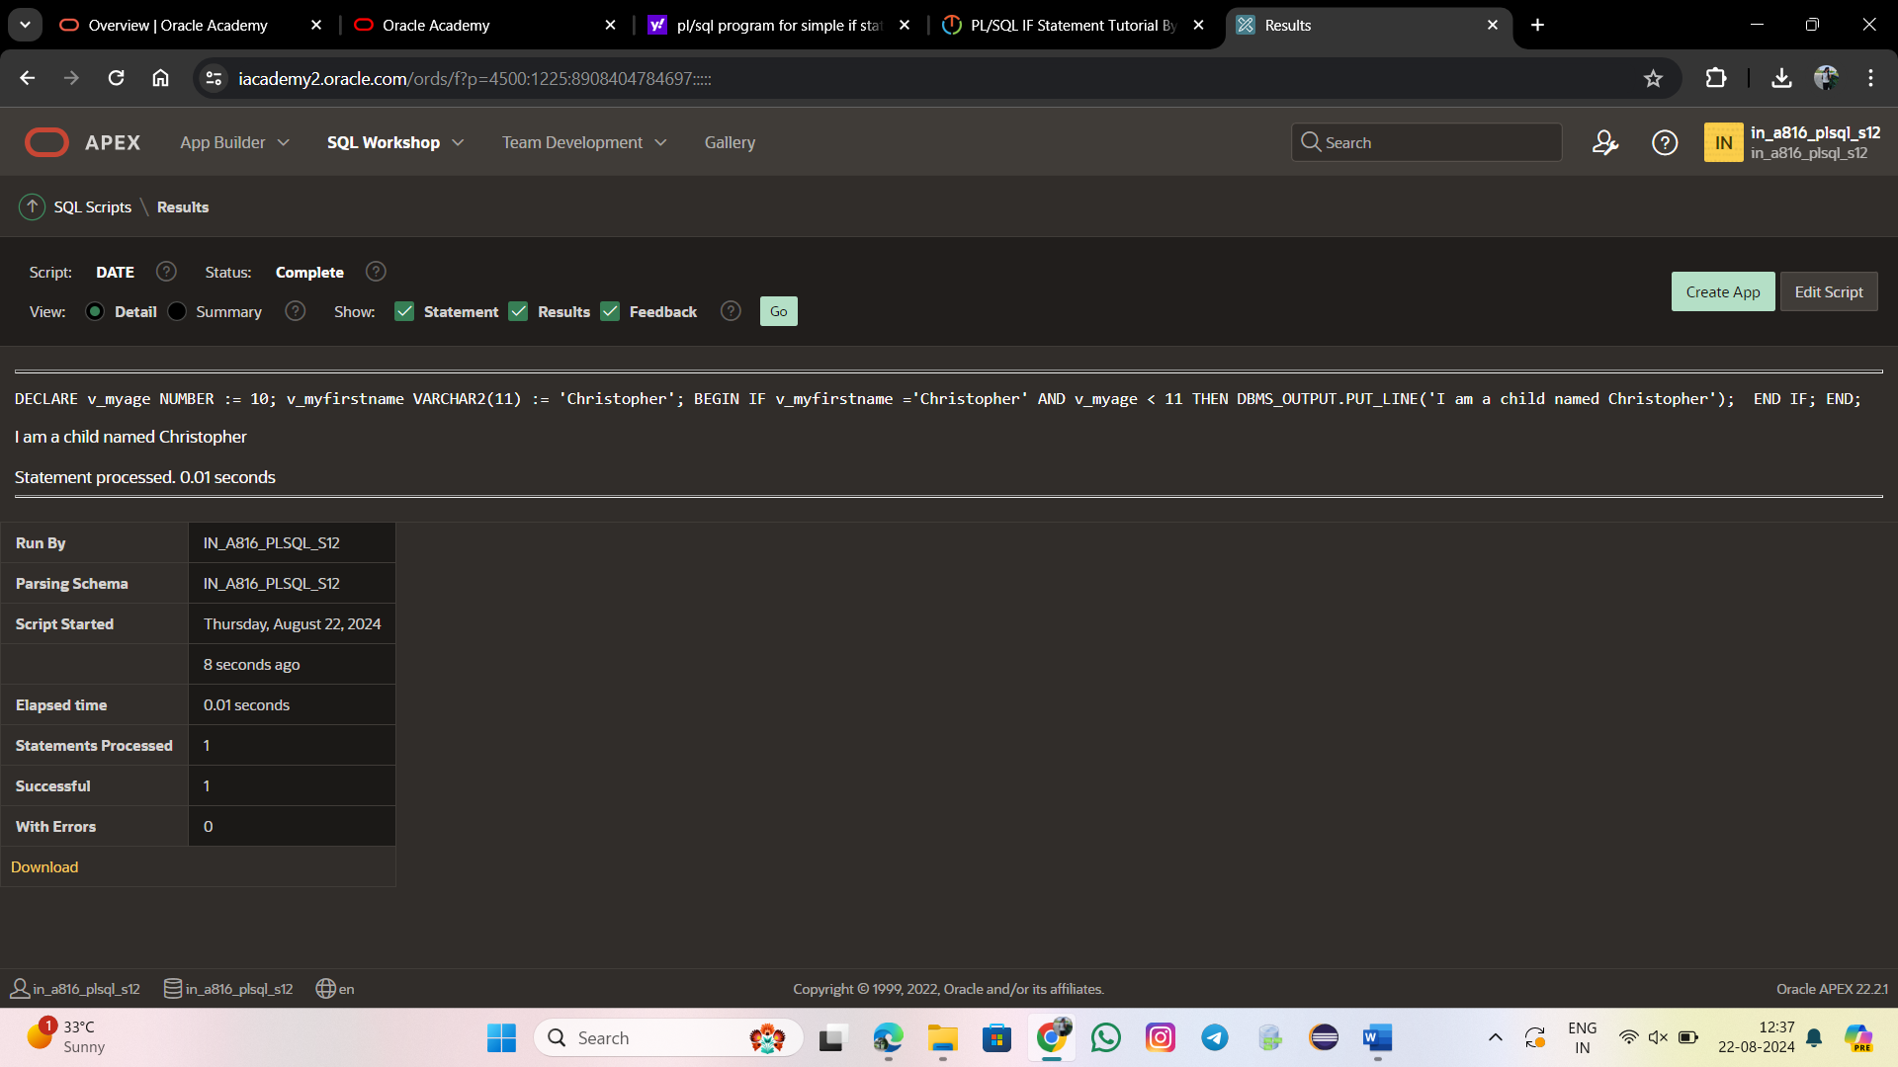

**NULL Values in IF Statements:**

DECLARE

v_myage NUMBER;

BEGIN

IF v_myage < 11

THEN

DBMS_OUTPUT.PUT_LINE('I am a child');

ELSE

DBMS_OUTPUT.PUT_LINE('I am not a child');

END IF;

END;

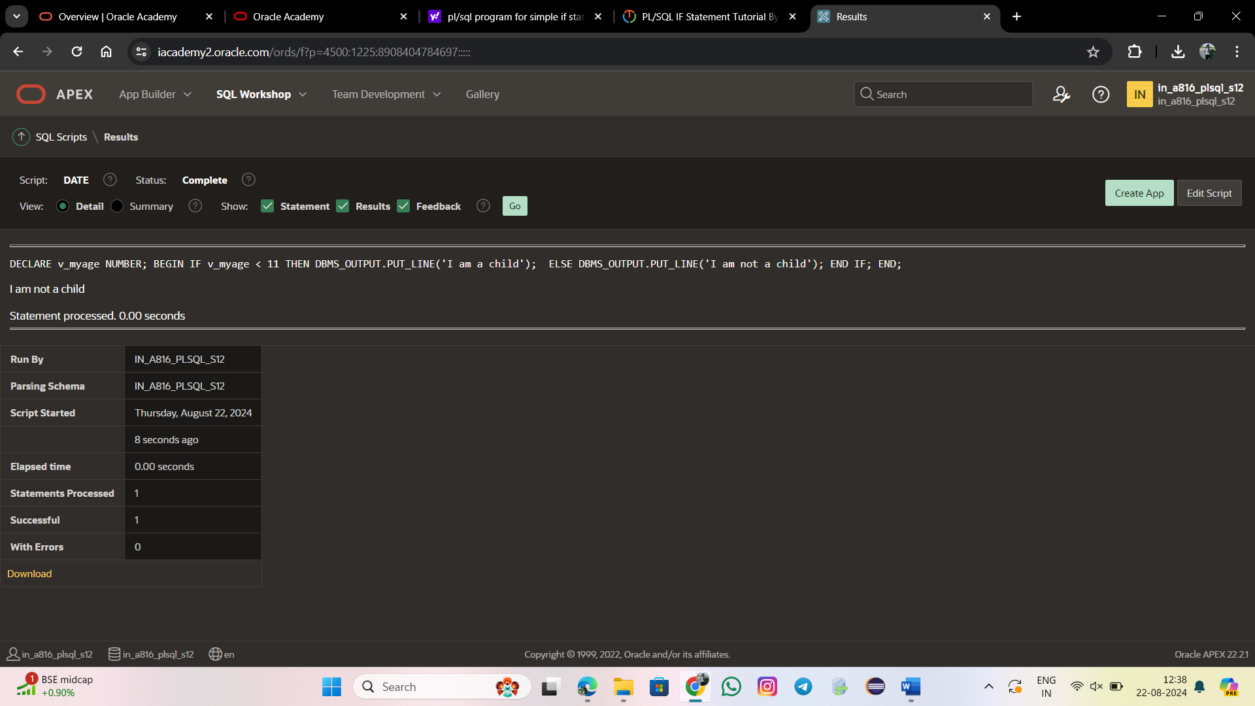

SELECT *

FROM FAMILYS

ORDER BY Age ASC;

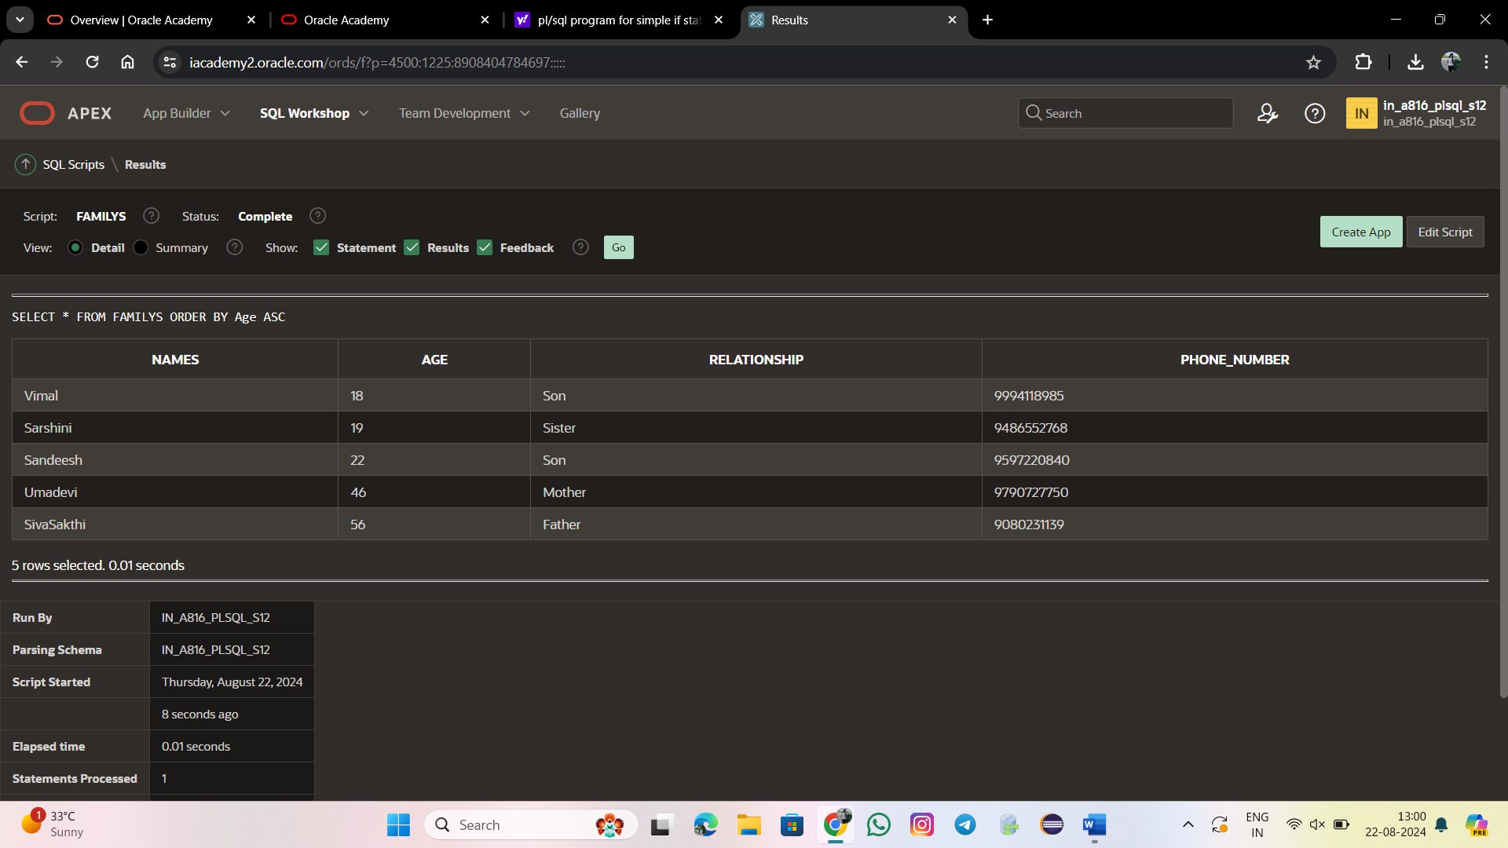

SELECT *

FROM FAMILYS

ORDER BY Age DESC;

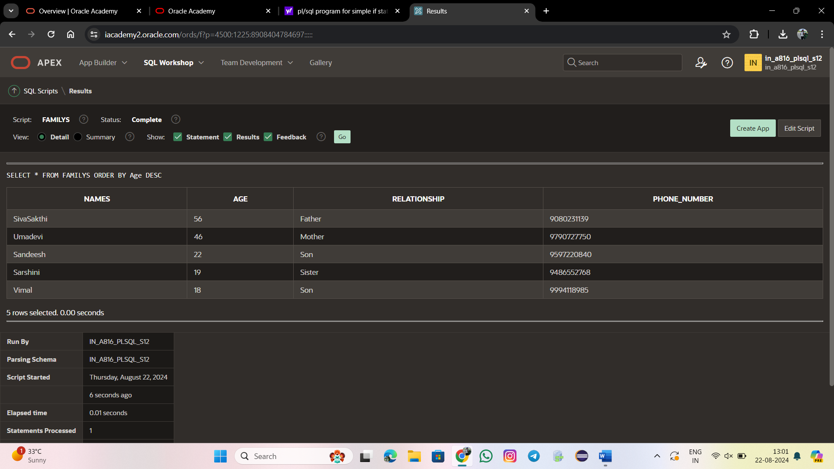

DECLARE

CURSOR my_cursor IS

SELECT Names,Age,Phone_Number

FROM FAMILYS

ORDER BY Age ASC;

my_record my_cursor%ROWTYPE;

BEGIN

OPEN my_cursor;

LOOP

FETCH my_cursor INTO my_record;

EXIT WHEN my_cursor%NOTFOUND;

DBMS_OUTPUT.PUT_LINE(my_record.Names|| ' ' ||my_record.Age|| ' ' ||my_record.Phone_Number);

END LOOP;

CLOSE my_cursor;

END;

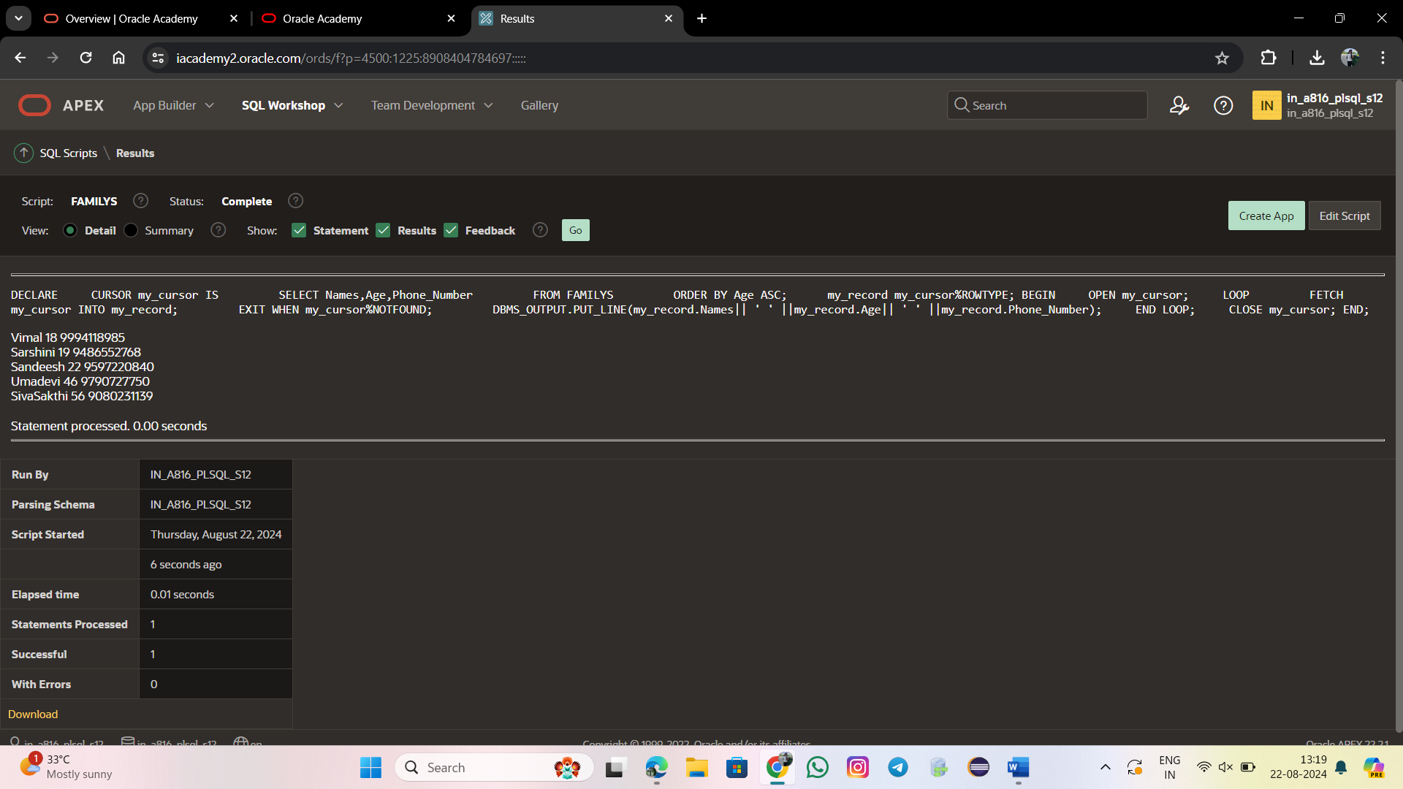

DECLARE

TYPE num_list_type IS TABLE OF NUMBER INDEX BY BINARY_INTEGER;

v_nums num_list_type;

BEGIN

v_nums(1) := 1;

v_nums(2) := 3;

v_nums(3) := 5;

v_nums(4) := 7;

v_nums(5) := 11;

FORALL i IN v_nums.FIRST .. v_nums.LAST

INSERT INTO ARRAY (n) VALUES (v_nums(i));

FOR i IN v_nums.FIRST .. v_nums.LAST

LOOP

DBMS_OUTPUT.PUT_LINE('Inserted ' || SQL%BULK_ROWCOUNT(i) || ' row(s) on iteration ' || i);

END LOOP;

END;

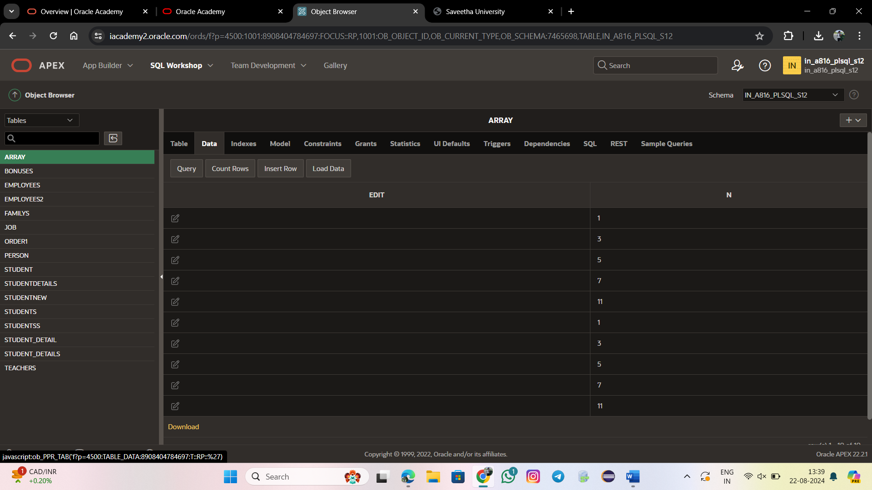

DECLARE

TYPE num_list_type IS TABLE OF NUMBER INDEX BY BINARY_INTEGER;

v_nums num_list_type;

v_nums1 num_list_type;

BEGIN

v_nums(1) := 1;

v_nums(2) := 3;

v_nums(3) := 5;

v_nums(4) := 7;

v_nums(5) := 11;

v_nums1(1) := 1;

v_nums1(2) := 3;

v_nums1(3) := 5;

v_nums1(4) := 7;

v_nums1(5) := 11;

FOR i IN v_nums.FIRST .. v_nums.LAST LOOP

FOR i IN v_nums1.FIRST .. v_nums1.LAST LOOP

INSERT INTO NUMS_ADDS (n, m, SUM_N_M)

VALUES (v_nums(i),v_nums1(i), v_nums(i) + v_nums1(i));

END LOOP;

END LOOP;

COMMIT;

FOR i IN v_nums.FIRST .. v_nums.LAST LOOP

DBMS_OUTPUT.PUT_LINE('Inserted ' || SQL%ROWCOUNT || ' row(s) in total.');

END LOOP;

END;

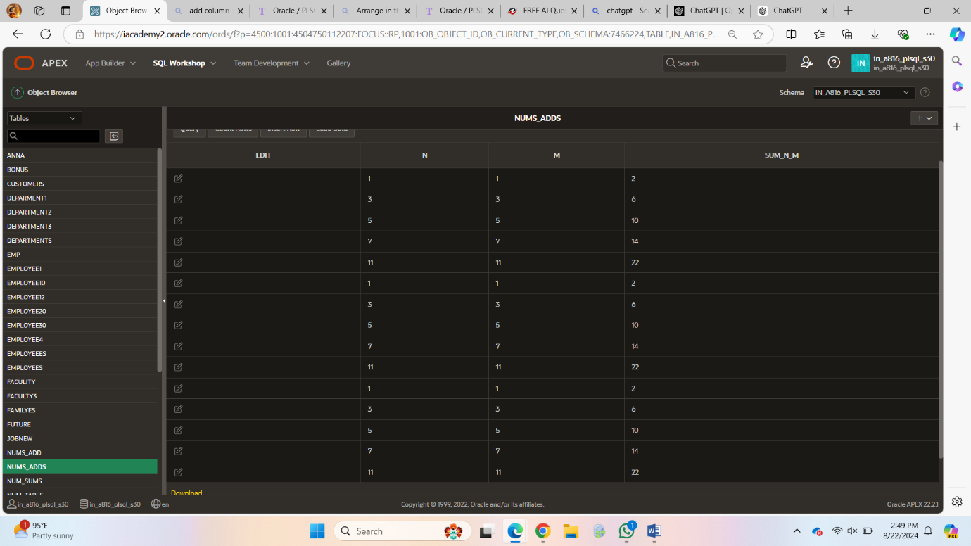

DECLARE

TYPE num_list_type IS TABLE OF NUMBER INDEX BY BINARY_INTEGER;

v_x num_list_type;

v_y num_list_type;

v_z NUMBER;

BEGIN

v_x(1) := 1;

v_x(2) := 3;

v_x(3) := 5;

v_x(4) := 7;

v_x(5) := 11;

v_y(1) := 2;

v_y(2) := 4;

v_y(3) := 6;

v_y(4) := 8;

v_y(5) := 12;

FOR i IN v_x.FIRST .. v_x.LAST LOOP

v_z := v_x(i) + v_y(i);

DBMS_OUTPUT.PUT_LINE('x: ' || v_x(i) || ', y: ' || v_y(i) || ' => z (x + y): ' || v_z);

END LOOP;

END;

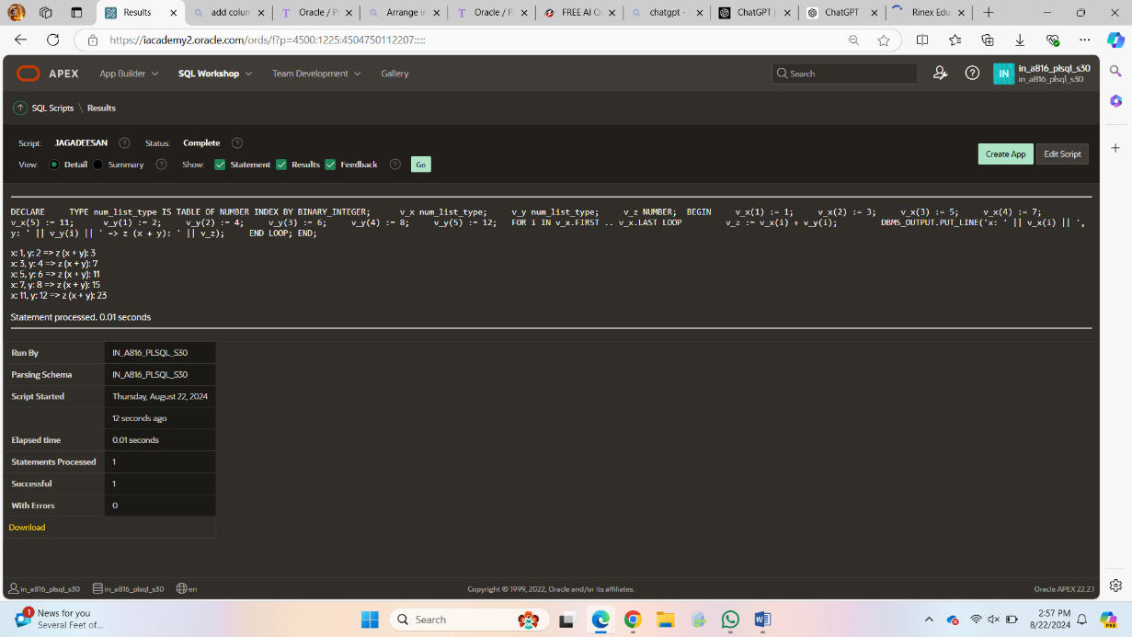

DECLARE

a number(2) := 30;

BEGIN

<<loopstart>>

WHILE a < 50 LOOP

dbms_output.put_line ('value of a: ' || a);

a := a + 1;

IF a = 35 THEN

a := a + 1;

GOTO loopstart;

END IF;

END LOOP;

END;

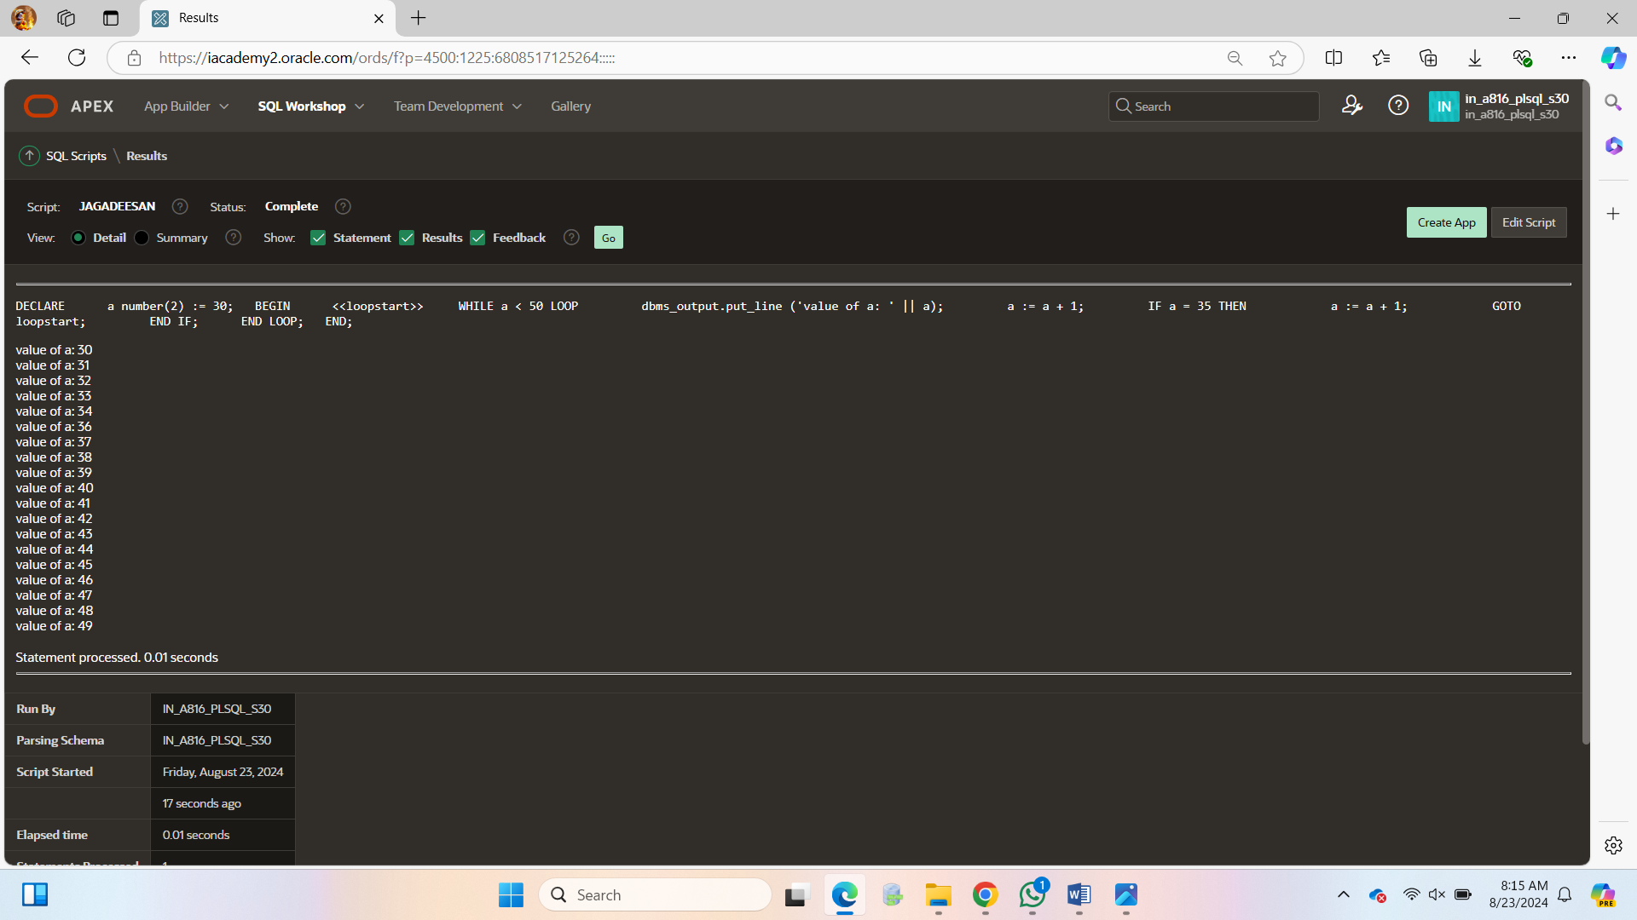

DECLARE

dividend NUMBER := 10;

divisor NUMBER := 0;

result NUMBER;

BEGIN

BEGIN

result := dividend / divisor;

DBMS_OUTPUT.PUT_LINE('Result: ' || result);

EXCEPTION

WHEN ZERO_DIVIDE THEN

DBMS_OUTPUT.PUT_LINE('Error: Division by zero');

END;

END;

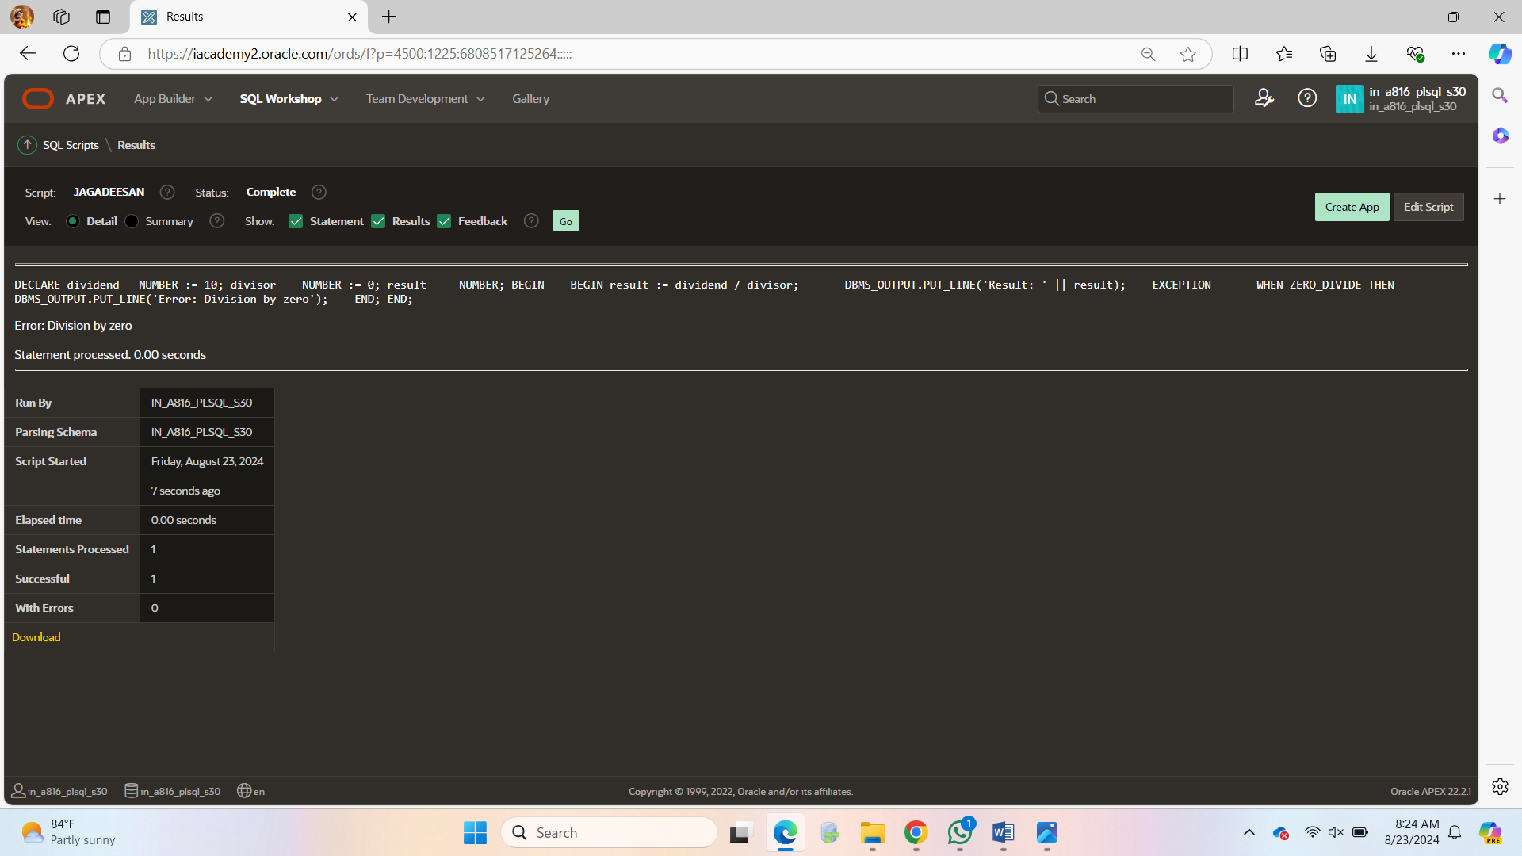

DECLARE

emp_name VARCHAR2(100);

emp_id NUMBER := 225;

BEGIN

BEGIN

SELECT first_name INTO emp_name FROM employee12 WHERE employee_id = emp_id;

DBMS_OUTPUT.PUT_LINE('Employee Name: ' || emp_name);

EXCEPTION

WHEN NO_DATA_FOUND THEN

DBMS_OUTPUT.PUT_LINE('Error: No matching record found');

END;

END;

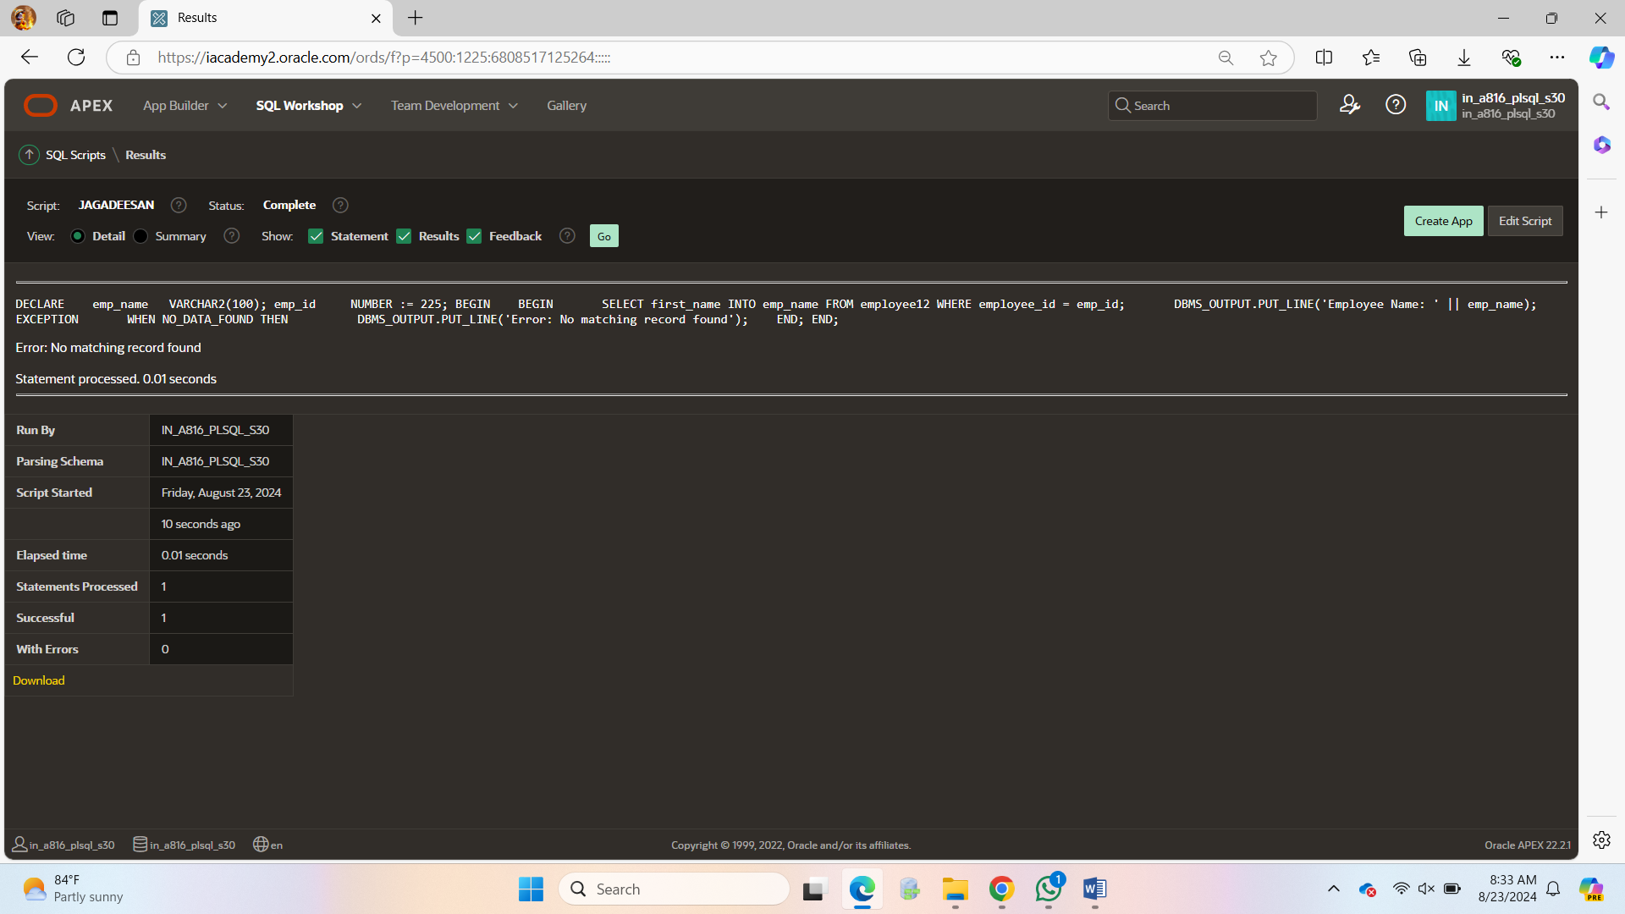

DECLARE

v_dep_id employee12.department_id%TYPE := 34;

v_emp_id employee12.employee_id%TYPE;

v_emp_name employee12.first_name%TYPE;

v_exception_msg VARCHAR2(200);

BEGIN

SELECT first_name, department_id

INTO v_emp_name,v_dep_id

FROM employee12

WHERE department_id = v_dep_id;

EXCEPTION

WHEN TOO_MANY_ROWS THEN

v_exception_msg := 'Multiple rows found for the given department ID: ' || v_dep_id;

DBMS_OUTPUT.PUT_LINE(v_exception_msg);

WHEN OTHERS THEN

v_exception_msg := 'An error occurred: ' || SQLERRM;

DBMS_OUTPUT.PUT_LINE(v_exception_msg);

END; 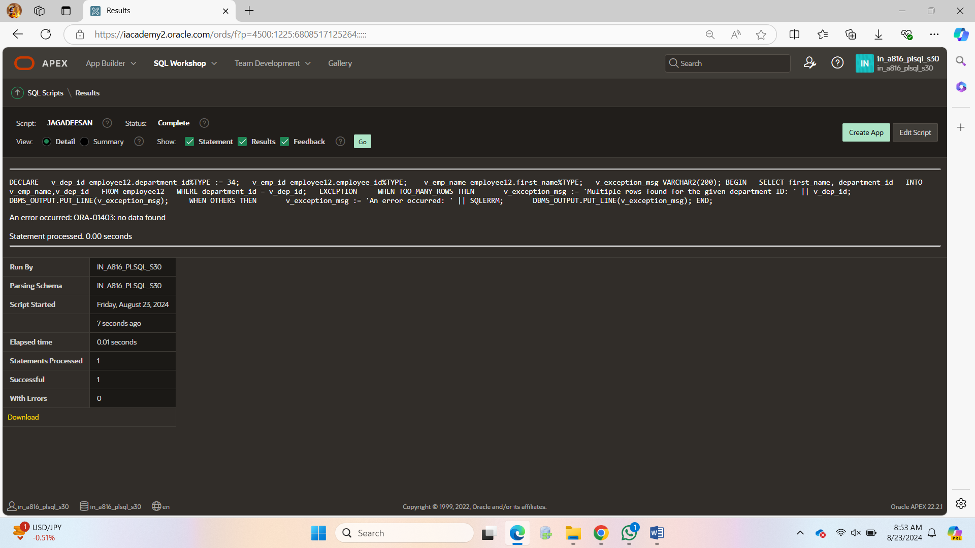

DECLARE

v_input VARCHAR2(10) := 'abc';

v_number NUMBER;

BEGIN

BEGIN

v_number := TO_NUMBER(v_input);

DBMS_OUTPUT.PUT_LINE('Conversion successful. Number: ' || v_number);

EXCEPTION

WHEN INVALID_NUMBER THEN

DBMS_OUTPUT.PUT_LINE('Error: Invalid number');

END;

EXCEPTION

WHEN OTHERS THEN

DBMS_OUTPUT.PUT_LINE('Error: ' || SQLERRM);

END;

